AIT 2A
Impact of video games on society
Mr. Faulks
Written by Daniel Oversby

Contents page
- When were the first video games produced and what companies invented them.

- What was the purpose of having these and what hardware was used to run them.

- How were these video games distributed to the community

- What changes to technology are likely to impact on video games in the future

- what are the impacts of video games on

- individuals
- community
- censorship laws

First Video Games There Creators and Purpose

In 1959 tx-0 experimental computer created mouse in the maze and tic-tac-toe. Mouse in the maze allowed users to use a light pen to place maze walls, and bits of cheese. A virtual mouse was then released and would run around the maze in order to find all the objects. Tic-tac-toe used a light pen also to play a simple game of tic-tac-toe against the computer
In 1961, spacewar was created on a mini-computer. The game, which is believed to be the first shooter game, spread to several of the early mini-computers. Russell has been quoted as saying that the aspect of the game that he was most pleased with was the number of other people now wanting to make games themselves.
In 1966, Ralph Baer continued work on his original idea he had in 1951 to make an interactive game on a T.V set. In May 1967, Baer and a partner created the first game to use a raster-scan display (television set) directly displayed by the change of a video signal. The brown box was released in May 1972 by Magnavox given the title Odyssey. It was the first home video game console.
Bill Pitts and Hugh Tuck made the first coin-operated computer game in 1971 ,called galaxy game, at Stanford University using a DEC PDP-11/20 computer.
Two months after Galaxy Game, Computer Space was released. It was created by Nolan Bushnell and Ted Dabney. It was actually the first coin operated video game sold in commercial quantities. Bushnell and Dabney's used a video display on a TV.

The original video games produced were solely for enjoyment purposes with very few used for anything else. They used very basic graphics and commands as well as not using high tech software and hardware to operate them. This made them basic and easy to program and operate.

First gaming computers

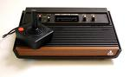
The atari VCS 2600was released in July 1977. It had no built in software and used two joysticks both with one fire button each. It used 6507 cpu and ran on 1.19 MHz of speed. It had 128 bytes of RAM and only 4KB of ROM. It used 160 x 192 graphics and had 128 different colors, 16 colors on 8 different intensity levels, and utilized two mono channels of sound. It had I/O ports for 2 controllers to plug in RF TV output and for the power. The atari 2600 ran off an external power supply.


The atari ST was released in 1985. It used a full-stroke keyboard and a motorola MC6800 cpu processor. It used a speed of 8 MHz and had only 512 KB of Ram and 192 KB of ROM. It used text modes of 40 or 80columns x 25 lines and graphic modes of 320 x 200 / 640 x 200 / 640 x 400 dots. It had I/o ports for RGB, TV modulator, Hard Disk, Floppy Disk, Joystick and Mouse. It contained built in media such as External 3.5'' 360 KB disk-drive. The atari ST ran off an external power supply. The cost for an atari ST ranged from 1,241.48 AUD to 661.344 AUD.

Impact of video games

Individuals:
Video games impact on people in different ways. There are some that can more or less impact on everyone in a particular way, and some that differ with age and what the individual is like. Video games have ratings for a reason, if games have a MA15+ rating it means they have content acceptable for a 15 yr old and older. One of the main problems that face the kids in this new generation is desensitization. One of the main reasons this happens is because they are watching material that is suitable to a much older age group and so therefore they see content that is suggested for people of an older maturity. Gaming addiction is a major threat to today’s society as more and more games are produced every second of the day. People are spending more time on computer than anything else. Apparently males spend about 13 hours a week on the computer or other video games. In America a teenager of about 13 was addicted to “halo”. He played for over three quarters of the day and skipped school to play. When his parents made him get off he shot them both killing them thinking that they would respawn later, as they did in “halo”.

Community:
People believe that avid video gamers have a negative impact on the community. It is said that people who play violent video games develop a more violent nature. some people believe that burglary’s and break ins have occurred in their community because in games it is accepted so when people face the real world they have no idea if it is right or wrong because in the games they played it was acceptable.

Censorship laws:

The E rating indicates material that is exempt from classification. Games exempt from classification are usually found online in which the content cannot be monitored and educational games.
The G rating indicates material that is for general audience. Violence must “have a low threat and be justified by context”, sexual activity, nudity and drug use may only be “very discreetly implied”, and coarse language must be “very mild and infrequent”.
The PG rating recommends parental guidance for a young audience. It is more relaxed in all categories. Violence should be mild and infrequent, and drug use and nudity. Coarse language must be mild.
The M rating is recommended for mature but young audiences, around the teen years. Language is relatively free, but “aggressive or strong coarse language” should be infrequent and sex may be mildly used, and there is slightly more violence. Drug use can be depicted
The “MA15+” rating is restricted to those 15 and over. It can contain strong gruesome violence, strong implication of sexual activity, much coarse language but “very coarse language” should be in frequent.

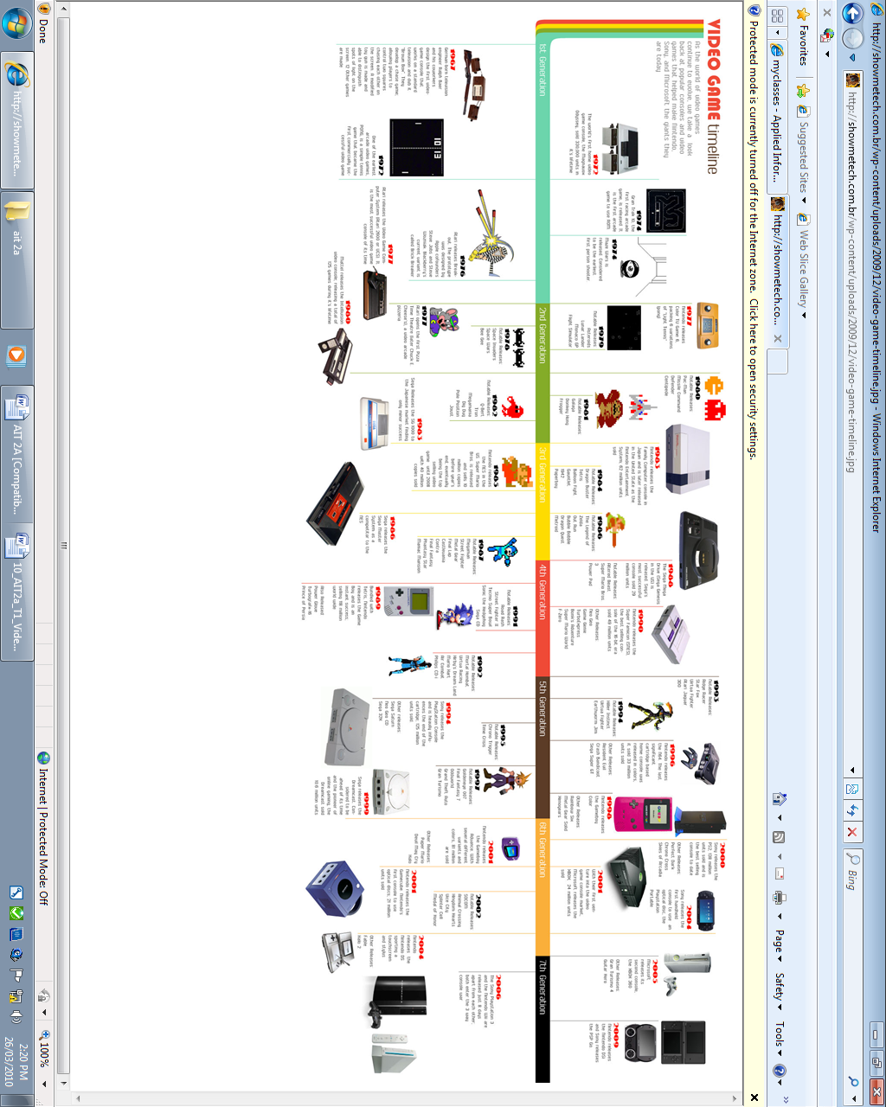

This time line was from
http://showmetech.com.br/wp-content/uploads/2009/12/video-game-timeline.jpg

Evaluation Individual Task

Copy and paste this into a new document: Save your evaluation as (your initials)_task?_eval into your task folder, or attach it to the web link site (if one is being used) or email it or show me at your computer before the end of the week.

Task AIT2a Video games in society 2010 Number 1

Your Name : Daniel Oversby Date 26/ 3/2010

1. What were you asked to do?
Answer: You are required to investigate and report on the impact of video games on our society over the last 20 years. Discuss the technology used, both past and present and consider future directions.
2. Who was your intended audience of your tasks?
Answerwhoever was interested in reading
3. How did you go about completing the task?
Answer: i was mildly pushed for time as i didnt use class time to full efficiency
4. If you were to complete the task again what would you do differently?
Answer: i would try to use my time more wisely and instead do it on one individual game
5. Any problems faced?
Answer: some of the imformation was relatively hard to find but got it in the end
6. What did you learn from this task?
Answer: basically eveything in the report was new to me

7.
How in-depth was your research?
□
I used a variety of ideas as inspiration and then developed my report
Answer:

8. Did you produce and keep draft copies of your report and your written response? (Should be linked to your web page)
Yes I did but I didn’t keep any copies

9. Did you keep a journal for this task?
□ Yes

10. What stood out as an interesting point of the task?
Answer:

11. Would you like to develop your skills in this task further, since completing this task?
□ maybe

12. Did you find any restrictions to your ability to manage this task?
Answer: better time management would surfice

13. Did you check your task for spelling and grammar mistakes?
□ Yes Why / Why not?
Answer:because you always should when handing in assignments
14. Any other comments – Did you enjoy this task?
□ Yes
Why / Why not?
Answer: because some of the facts i found out were pretty interesting

15. How did you feel about your time management for this task?
□
It took me about the same time suggested in the course to complete my event item

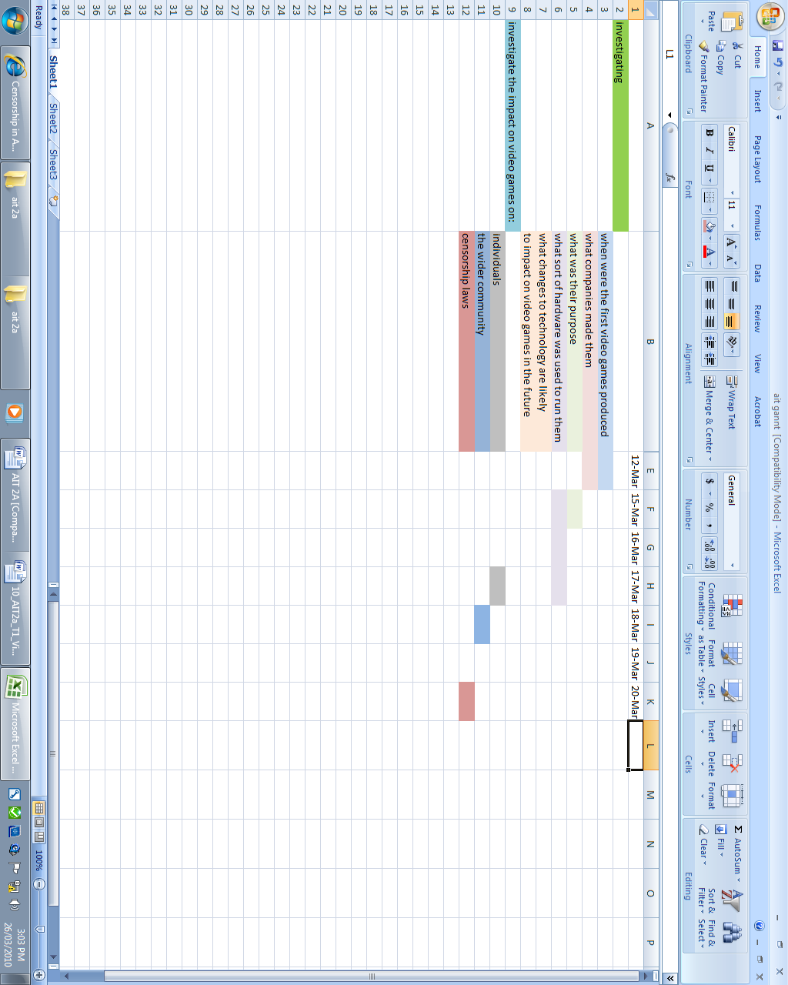

http://en.wikipedia.org/wiki/First_video_game
http://www.old-computers.com/museum/computer.asp?c=20
http://www.old-computers.com/museum/computer.asp?c=878&st=2

